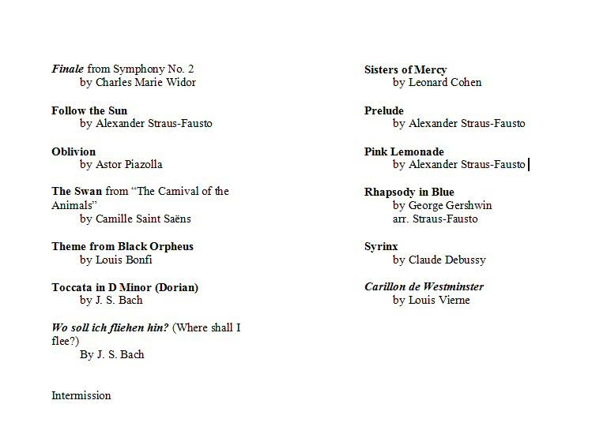
Encore: The Rev’d Mustard his Installation Prelude
by Nico Muhly
Encore 2: Fantasie on Oh Canada
by Denis Bedard

